Use this family tree to say how the people on the next page are related to RODRIGO (Bottom left)

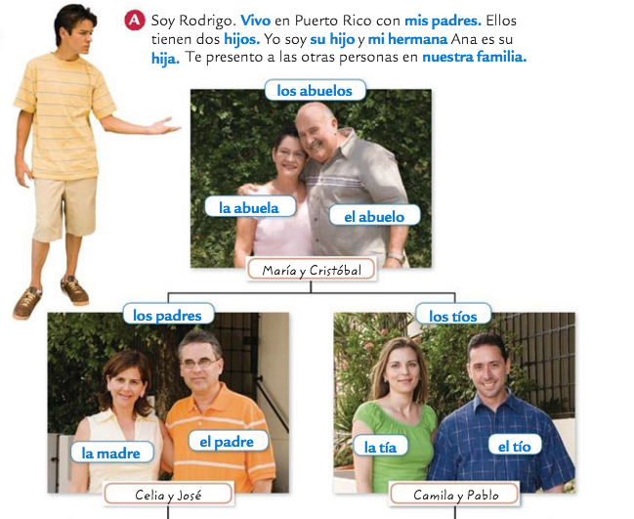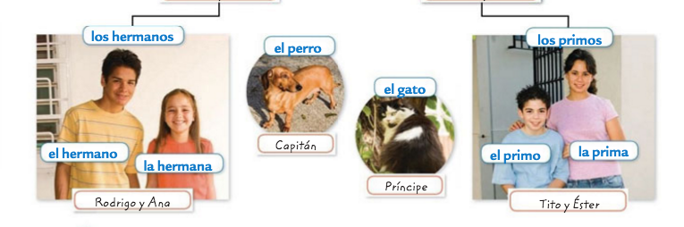
Use the family tree on the first page to say how the people on here are related to RODRIGO (Bottom left of the family tree)

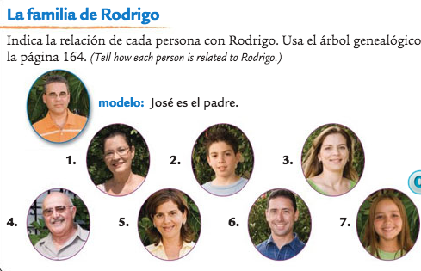
- Maria

- Tito

- Camila

- Cristobal

- Celia

- Pablo

- Ana

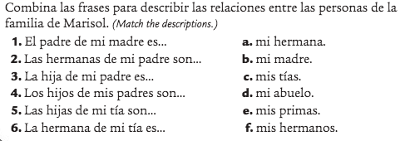
1.
2.
3.
4.
5.
6.

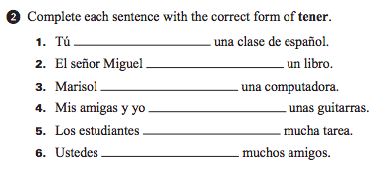
1.
2.
3.
4.
5.
6.

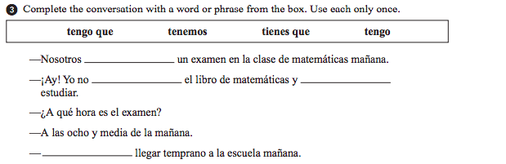
1.
2.
3.
4.

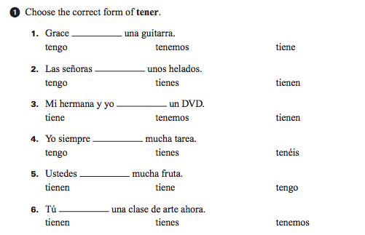
1.
2.
3.
4.
5.
6.
Now translate the following sentences using the tener idioms and your family vocabulary:

- My Aunt is thirsty.

- Usted tiene suerte en videojuegos.

- My sister and brother are sleepy.

- Mis primos tienen ganas de jugar al fútbol

- I have to study Spanish.

- Nosotros tenemos miedo de serpientes.

- You (inf) are excited to rest.

- Mi abuela tiene que preparer la comida

- Y’all are hungry.

Write a sentence describing the following people. Make sure to tell me their: hair color, eye color, and a personal description

Beyonce

Ellen Degeneres

Eleven: stranger things 2
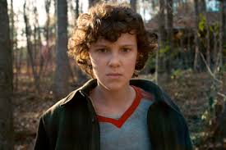

Ed Sheeran

Obama

Katy Perry

