Step 1:
Take your 3 papers and fold them into thirds like in the picture below (Label the back of the three –AR endings, -ER endings, and –IR endings)
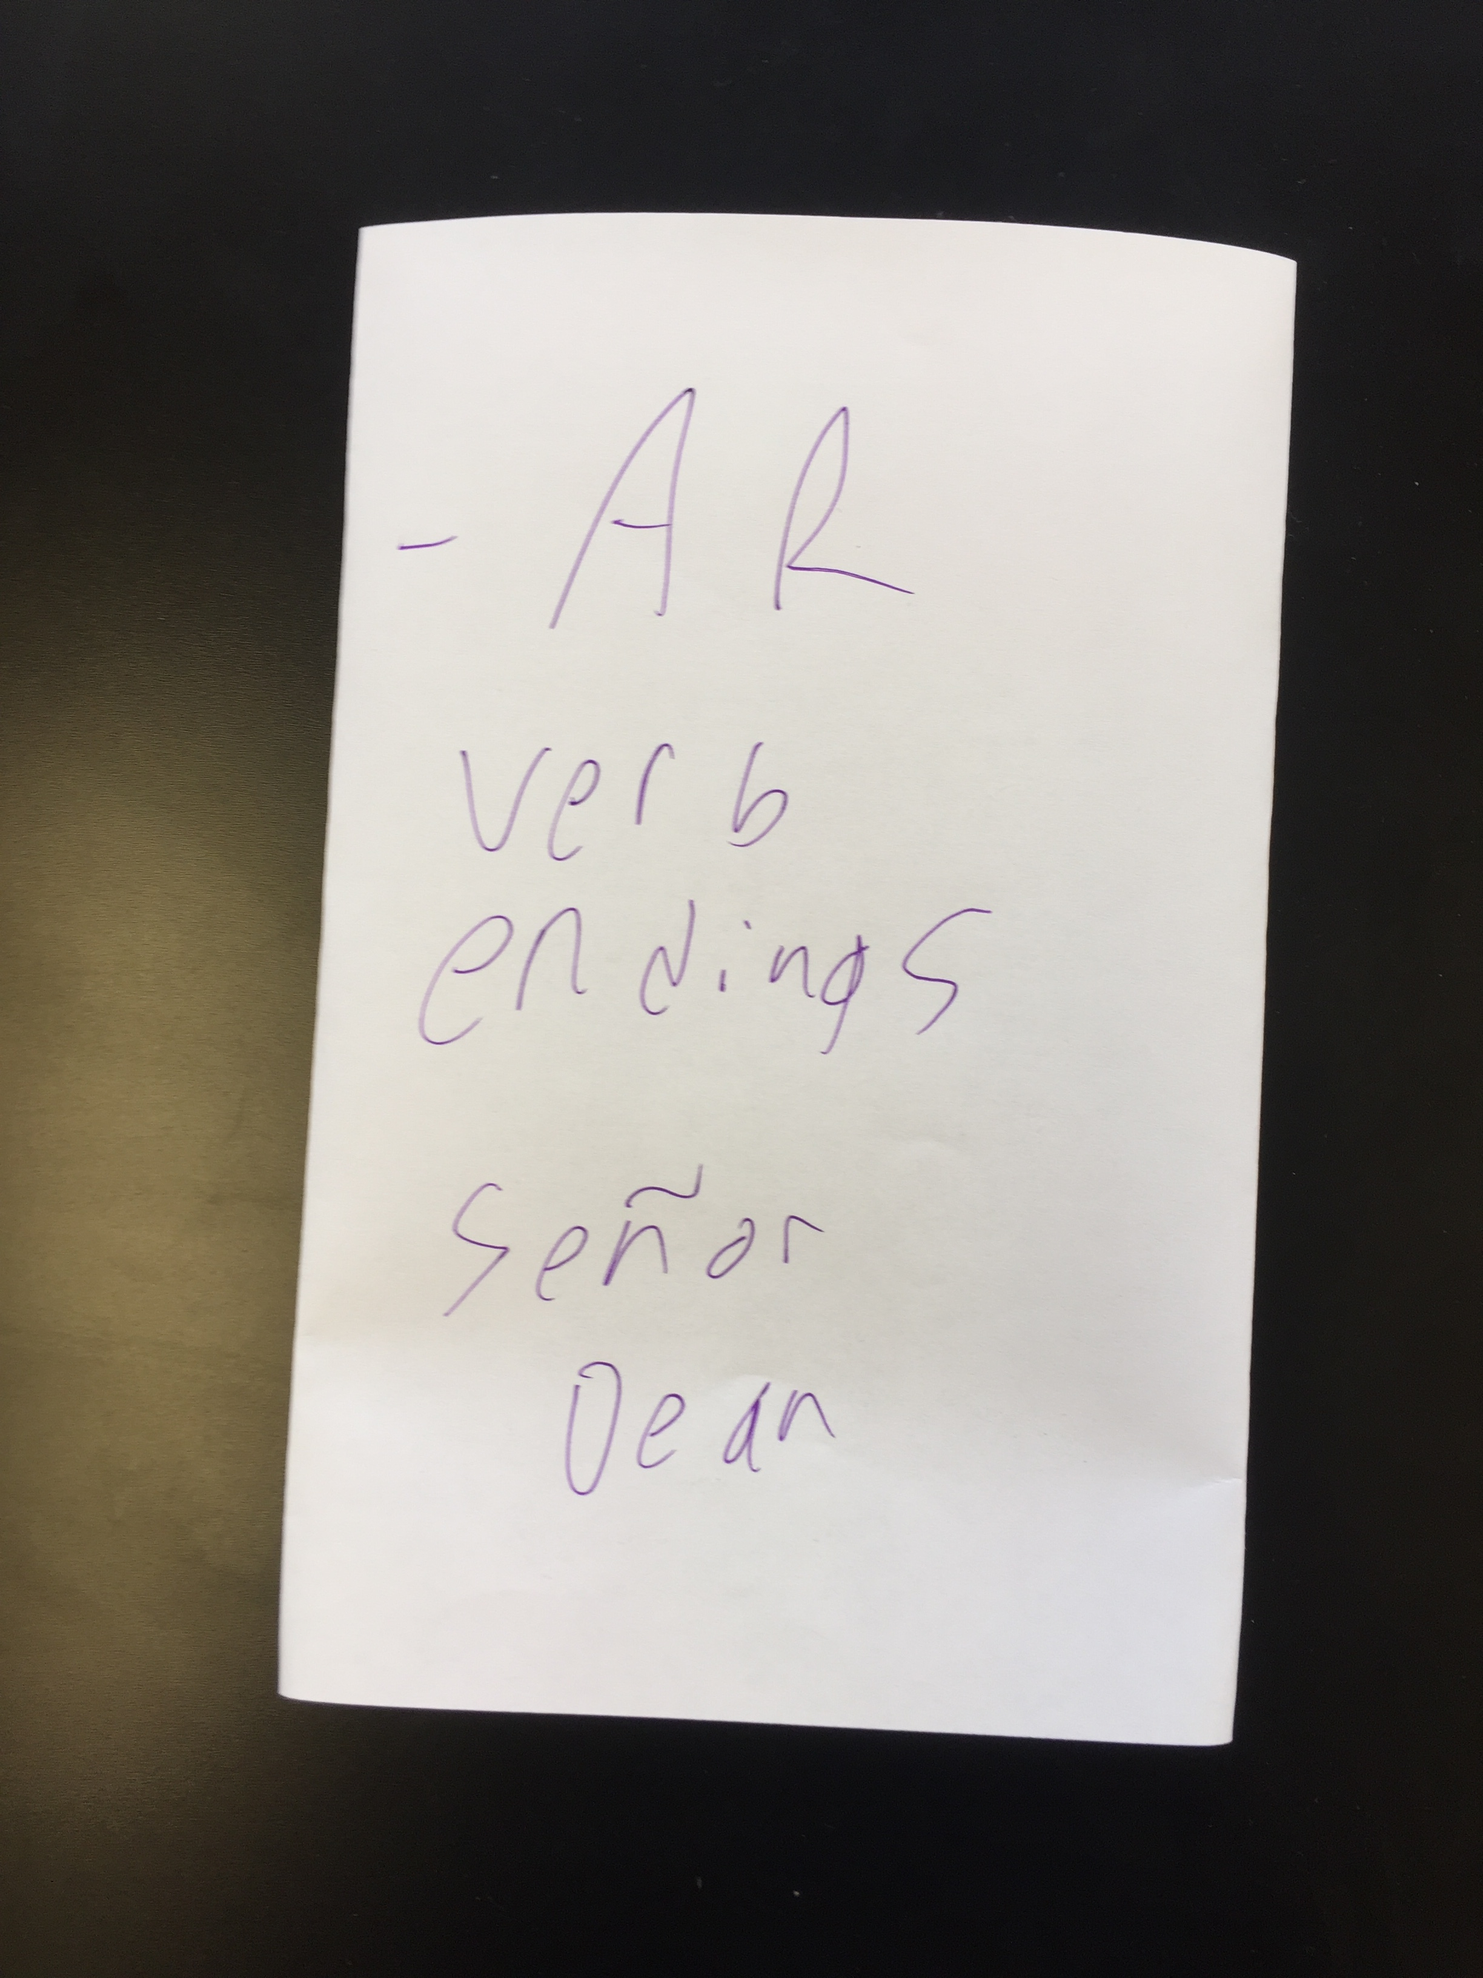(Back)
Step 2:
Cut each of the outside flaps twice (leaving the bottom flap a little bigger than the rest)
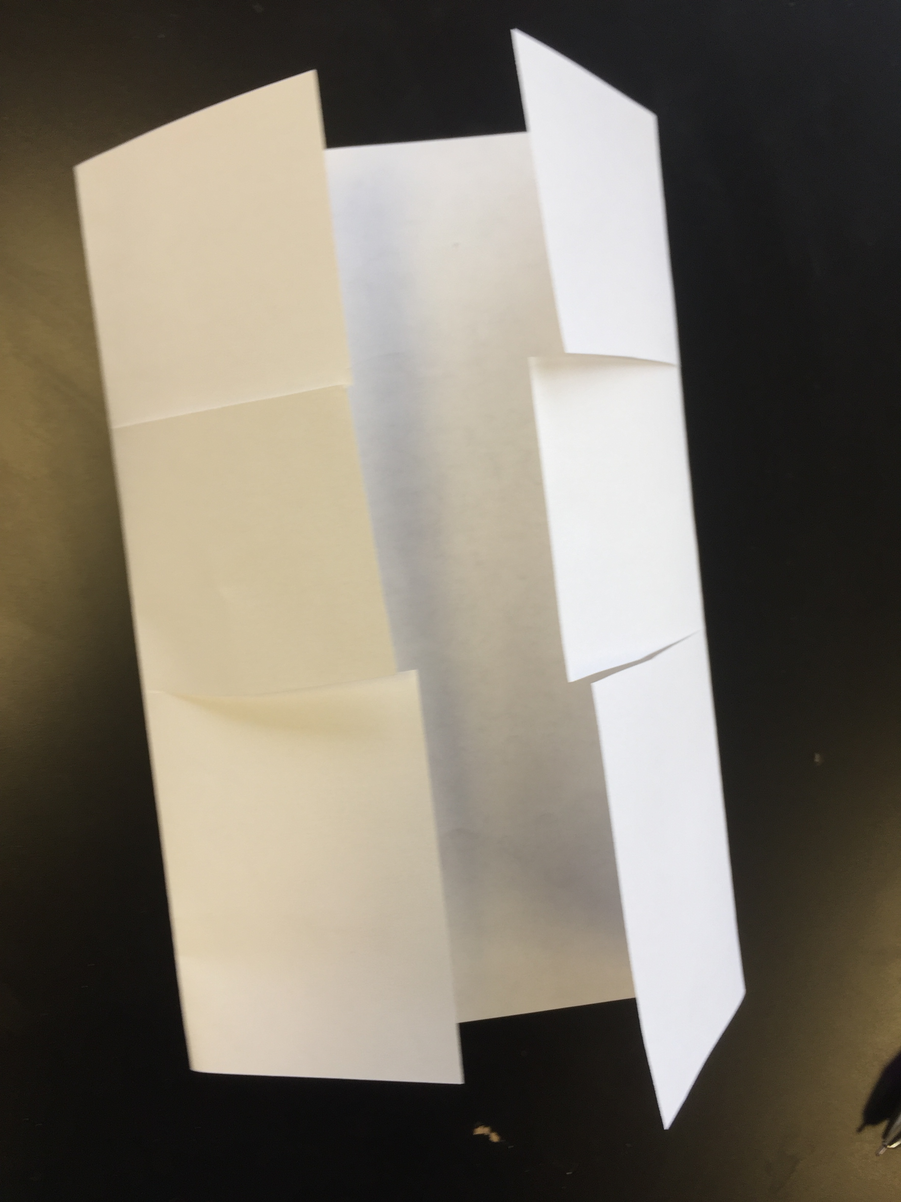
Step 3:
Close the flaps and write the subject pronouns on the outside.
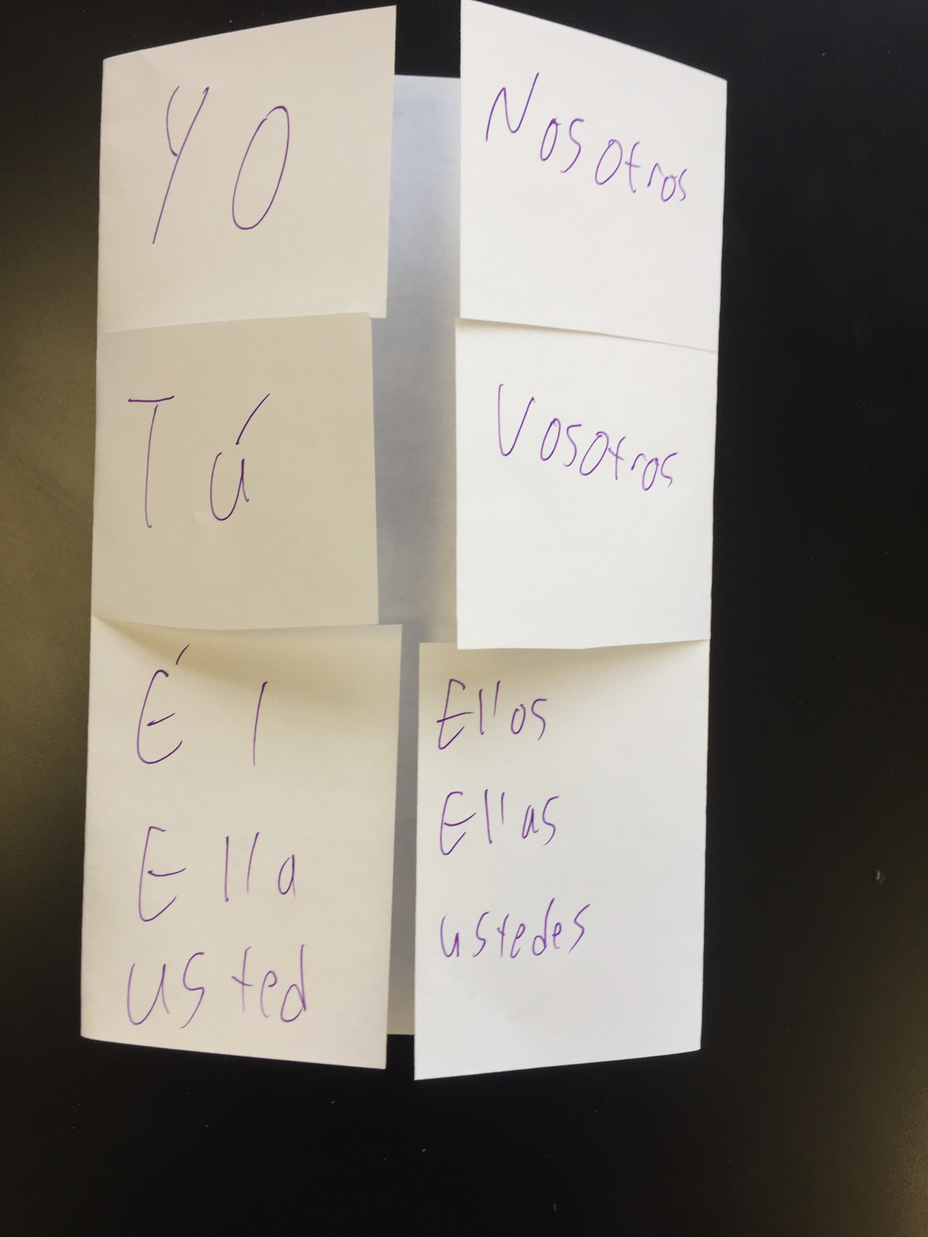

Step 4: Write on the inside of the flap (opposite side of the subject pronoun) what that subject pronoun means
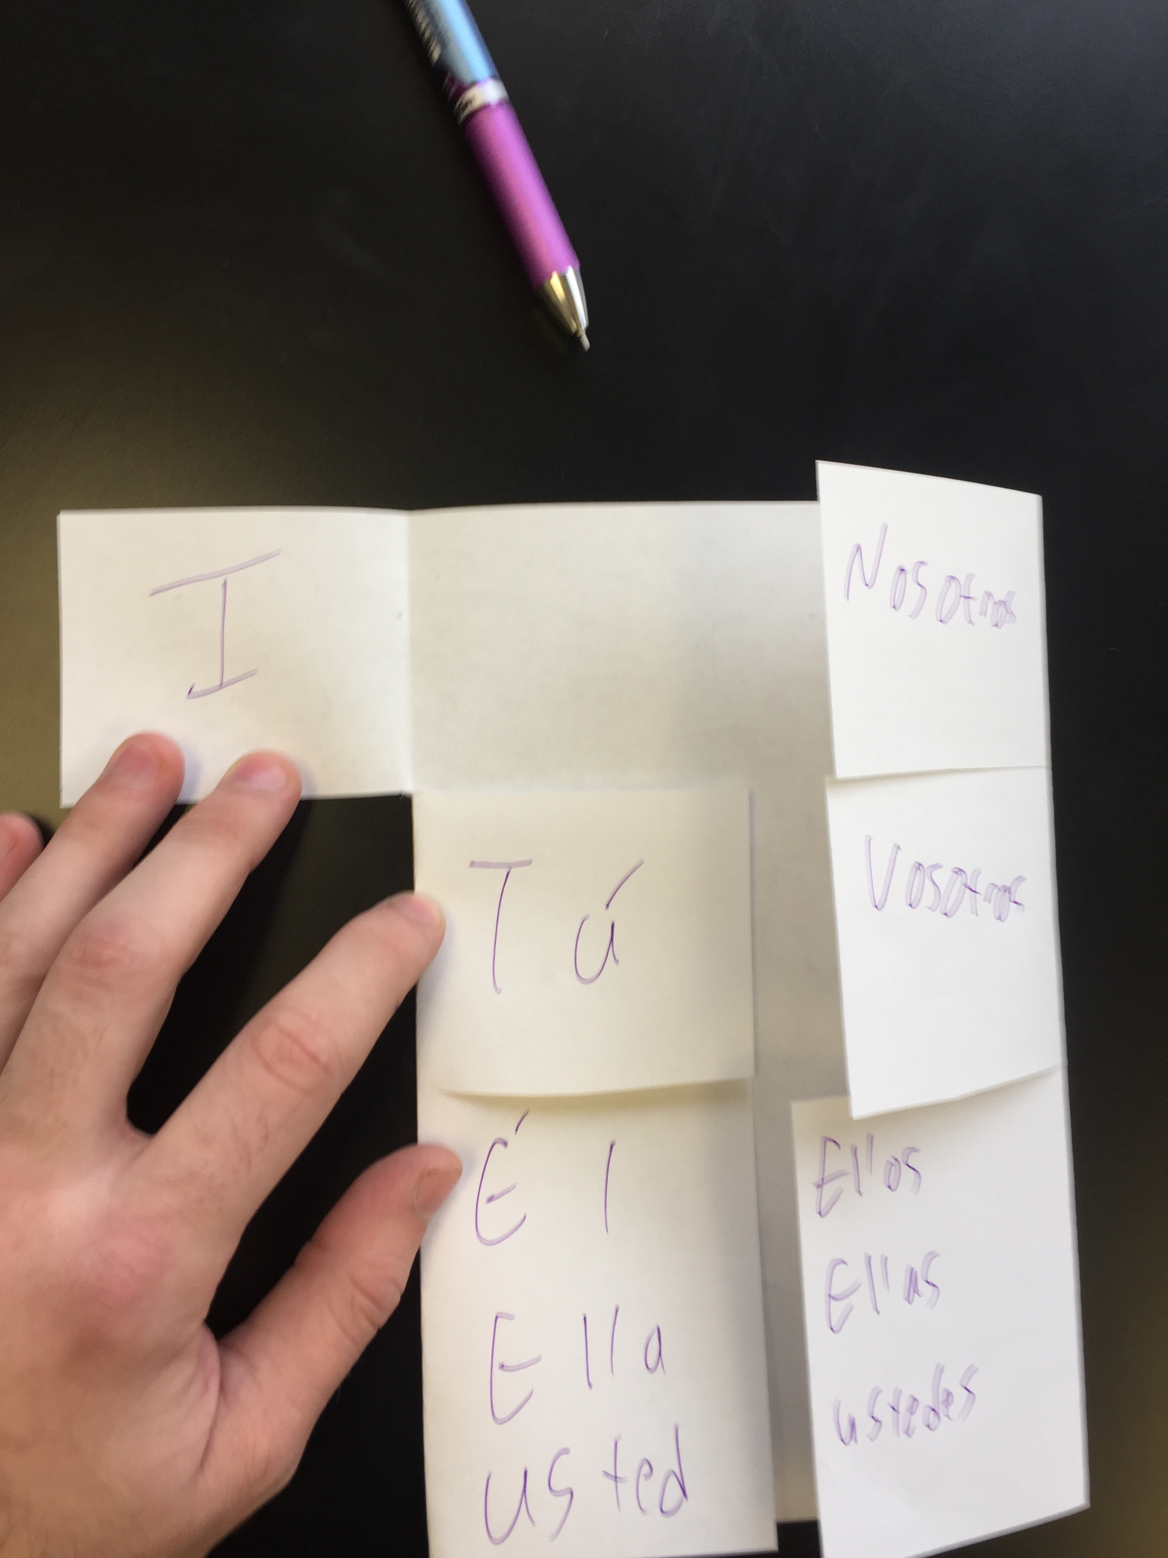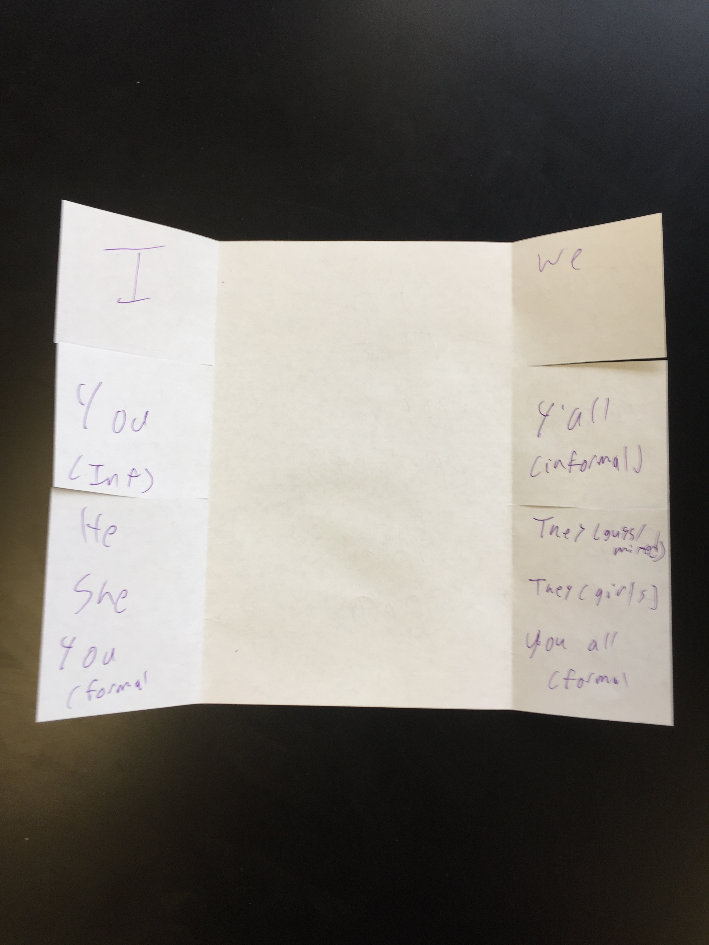
Step 5:
In the middle (uncut part of the page) the conjugated endings that go with that subject pronoun AND an example of a conjugated verb
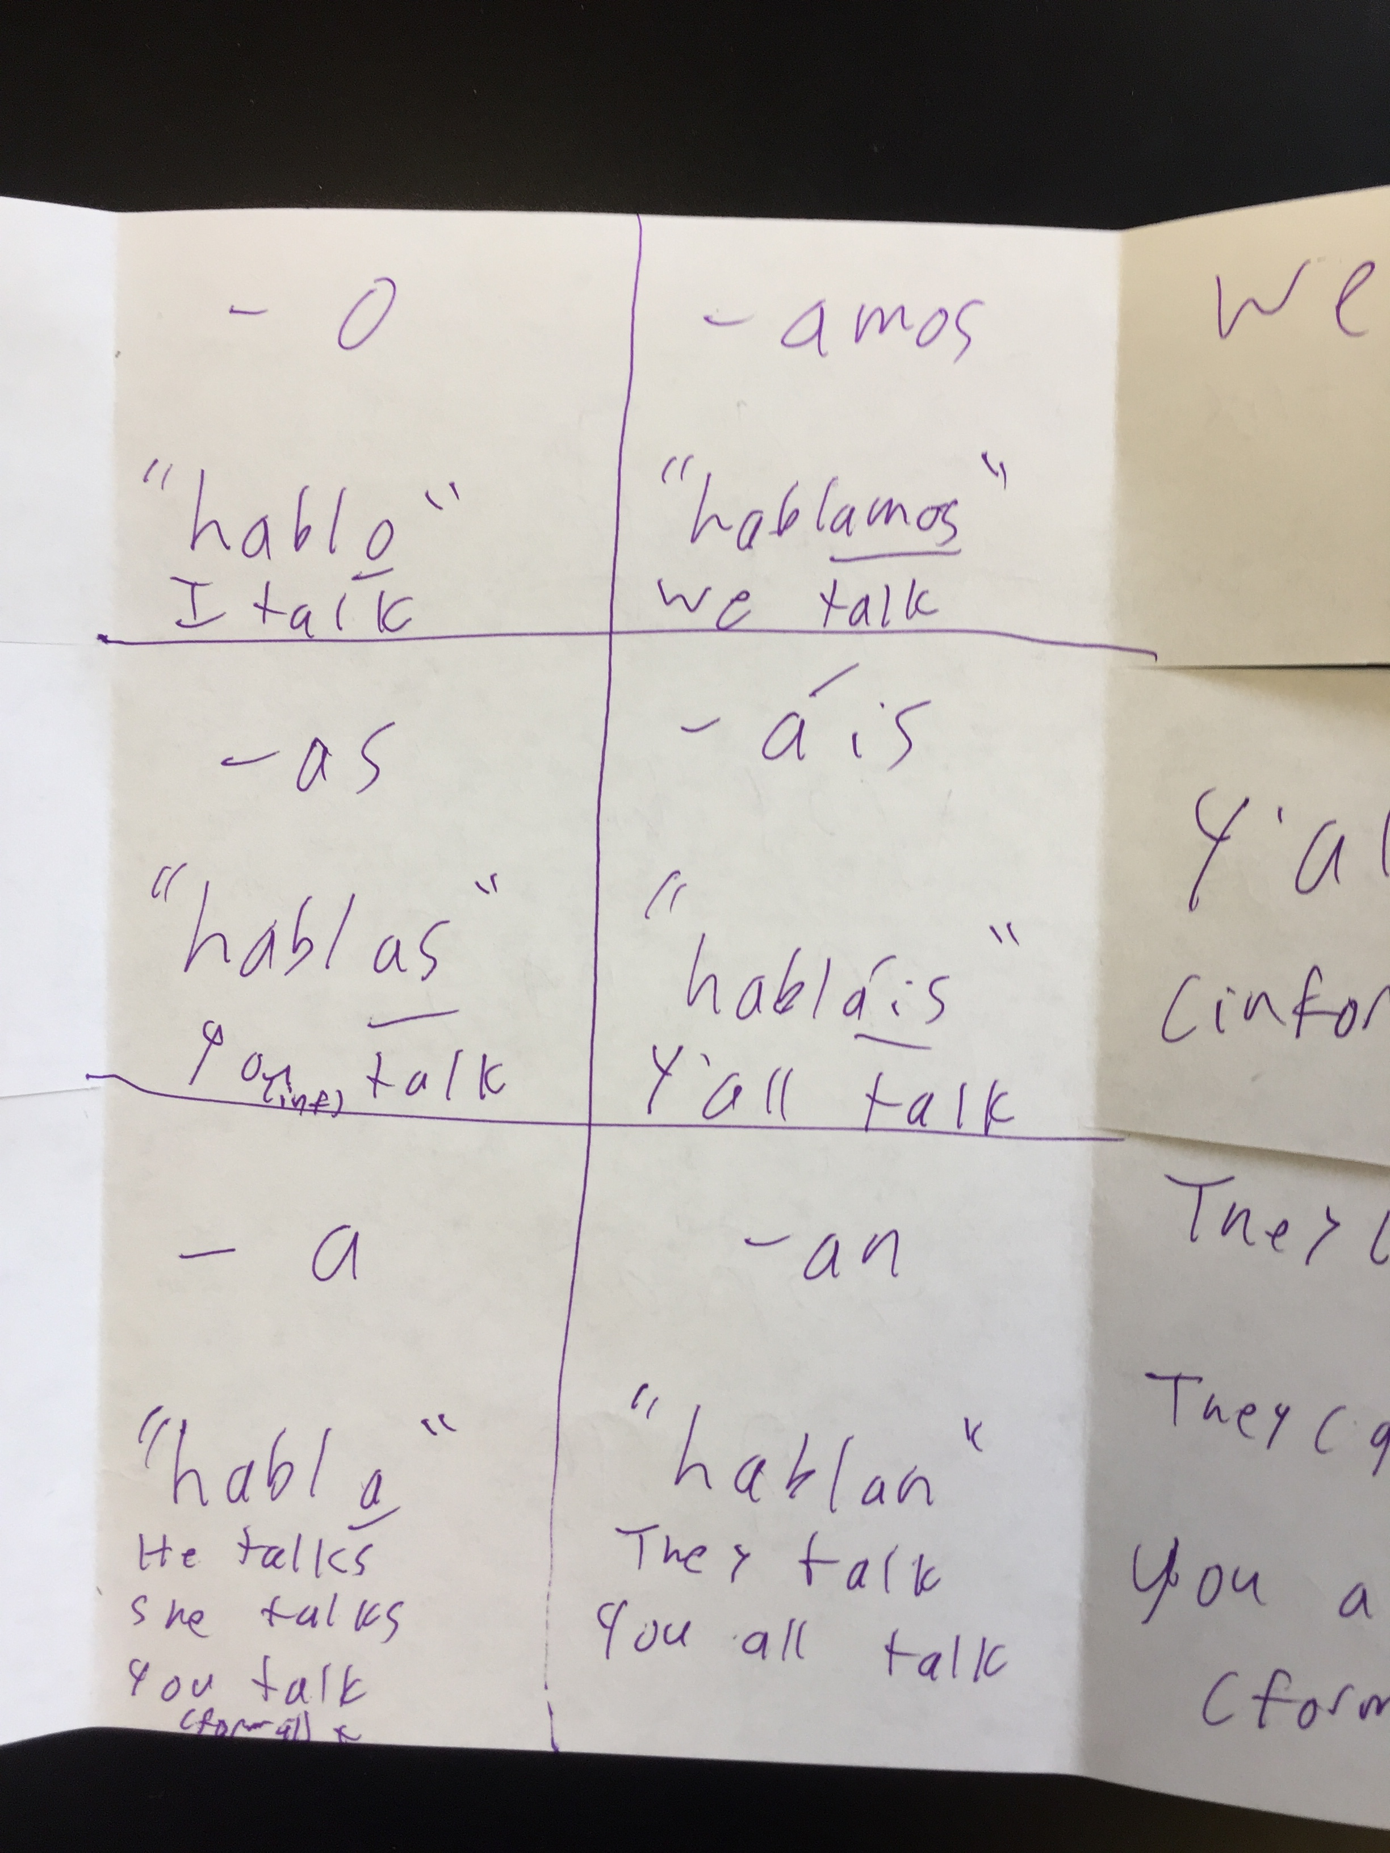
Step 6: use to study

