Reflexives: what you do to yourself
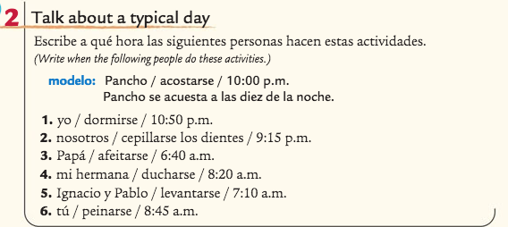
Write sentences conjugating the verb for the person given.

1.

2.

3.

4.

5.

6.

Write 3 sentences IN SPANISH describing how you get ready for school in the morning OR how you get ready for bed at night.

Chores: what you have to do
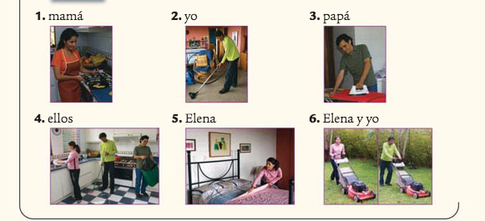

Write sentences describing what these people are doing. CONJUGATE THE VERB FOR THE PEOPLE DOING THE ACTIVITY

1.

2.

3.

4.

5.

6.

Now write 5 sentences IN SPANISH using our “Suggestion phrases” for what chores you have to do at home.

Commands: what you tell other people to do
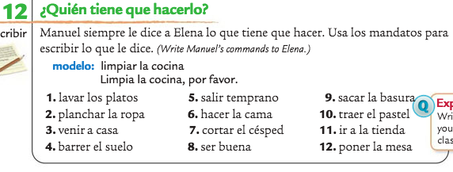
Change these chores into their COMMAND tense

1.

2.

3.

4.

5.

6.

7.

8.

9.

10.

11.

12.

Now write 5 commands you might hear in Spanish class

1.

2.

3.

4.

5.

